**­REPORT**

|  |
| --- |
| **Part 1: Zener shunt regulator** |

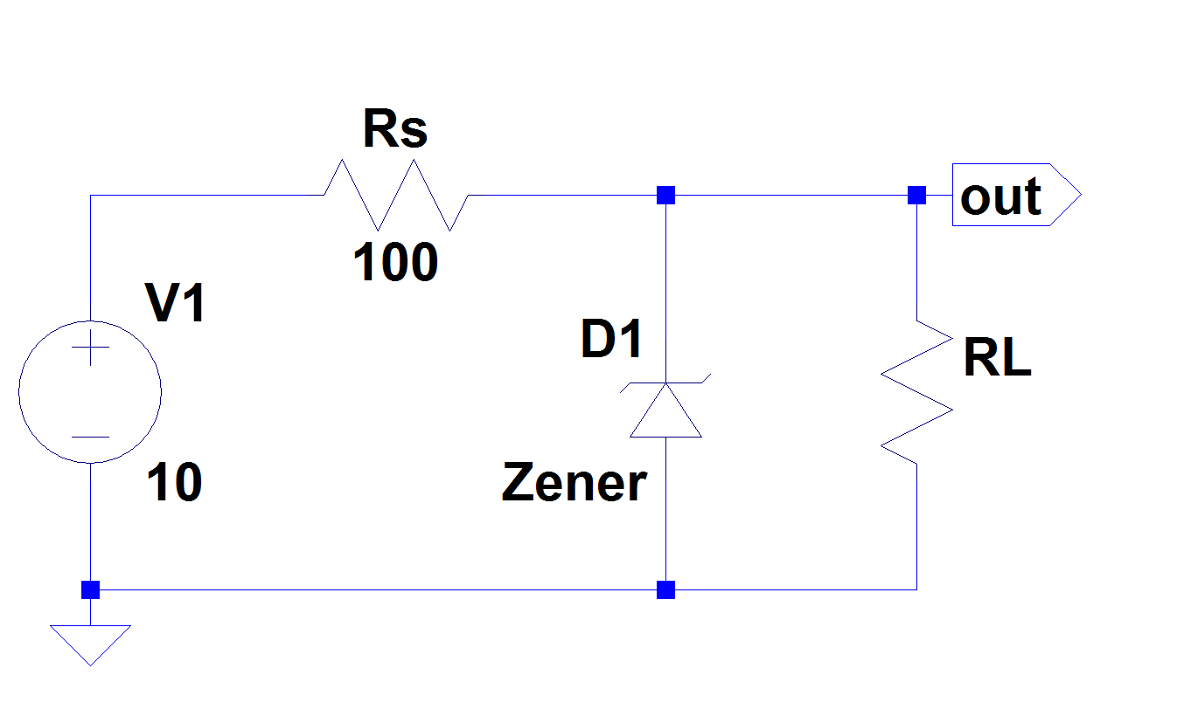

|  |  |  |  |  |  |
| --- | --- | --- | --- | --- | --- |
| RL (Ω) | open (no loading) | 1k | 166 | 100 | 50 |
| Vout (V) | 7.58 | 7.56 | 6.15 | 5 | 3.36 |
| Iout (A) | 0 | 7.5m | 37.8m | 48.3m | 63.5m |
| ΔVout (V) |  | -0.02 | -1.43 | -2.58 | -4.22 |
| ΔIout (A) | 7.5m | 37.8m | 48.3m | 63.5m |
| LOR (Ω) | -2.67 | -37.83 | -53.42 | -66.46 |

|  |
| --- |
| **Part 2: 78/79 Series regulator ( soldered on perfboard )** |

7805 IC (**+5 V output**)

|  |  |  |  |  |  |
| --- | --- | --- | --- | --- | --- |
| RL (Ω) | open  (no loading) | 1k | 100  (**high power Resistor**) | 25  (**high** **power Resistor**) | 10  (**high power Resistor**) |
| Vout (V) | 5.22 | 5.11 | 5 | 5.05 | 4.8 |
| Iout (A) | 0 | 5m | 45.9m | 146.7m | 450m |
| ΔVout (V) |  | -0.11 | -0.22 | -0.17 | -0.42 |
| ΔIout (A) | 5m | 45.9m | 146.7m | 450m |
| LOR (Ω) | -22 | -4.79 | -1.16 | -0.93 |

7812 IC

|  |  |  |  |  |  |
| --- | --- | --- | --- | --- | --- |
| RL (Ω) | open  (no loading) | 1k | 166 | 100  (**high power Resistor**) | 50  (**high power Resistor**) |
| Vout (V) | 11.9 | 11.9 | 11.86 | 11.84 | 11.83 |
| Iout (A) | 0 | 11.7m | 70.9m | 108.5m | 220m |
| ΔVout (V) |  | 0 | -0.04 | -0.06 | -0.07 |
| ΔIout (A) | 11.7m | 70.9m | 108.5m | 220m |
| LOR (Ω) | 0 | -0.56 | -0.55 | -0.32 |

7912 IC

|  |  |  |  |  |  |
| --- | --- | --- | --- | --- | --- |
| RL (Ω) | open  (no loading) | 1k | 166 | 100  (**high power Resistor**) | 50  (**high power Resistor**) |
| Vout (V) | -12.15 | -12.14 | -12.13 | -12.09 | -12.09 |
| Iout (A) | 0 | -12.1m | -73.7m | -108.2m | -240m |
| ΔVout (V) |  | 0.01 | 0.02 | 0.06 | 0.06 |
| ΔIout (A) | -12.1m | -73.7m | -108.2m | -240m |
| LOR (Ω) | -0.83 | -0.27 | -0.55 | -0.25 |

Implemented Circuit schematic (i.e. the practical circuit you show to TA):

